You may Access by clicking this link:
https://asambleaeclesial.lat/escucha/

1
To be able to access the system you must be registered. In order to do that please use the button to create your user account.

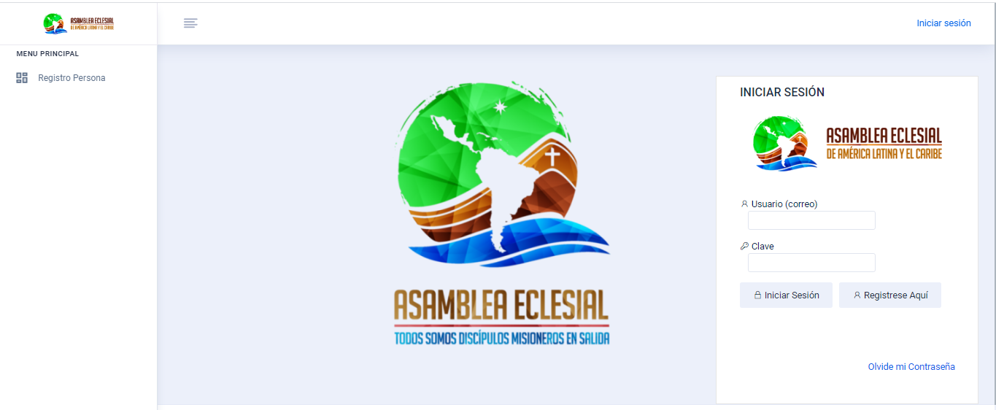

2
Once you have clicked the Register Here button, the system will display the registration form.

The fields that contain an asterisk (*), are mandatory. You must fill in this information.
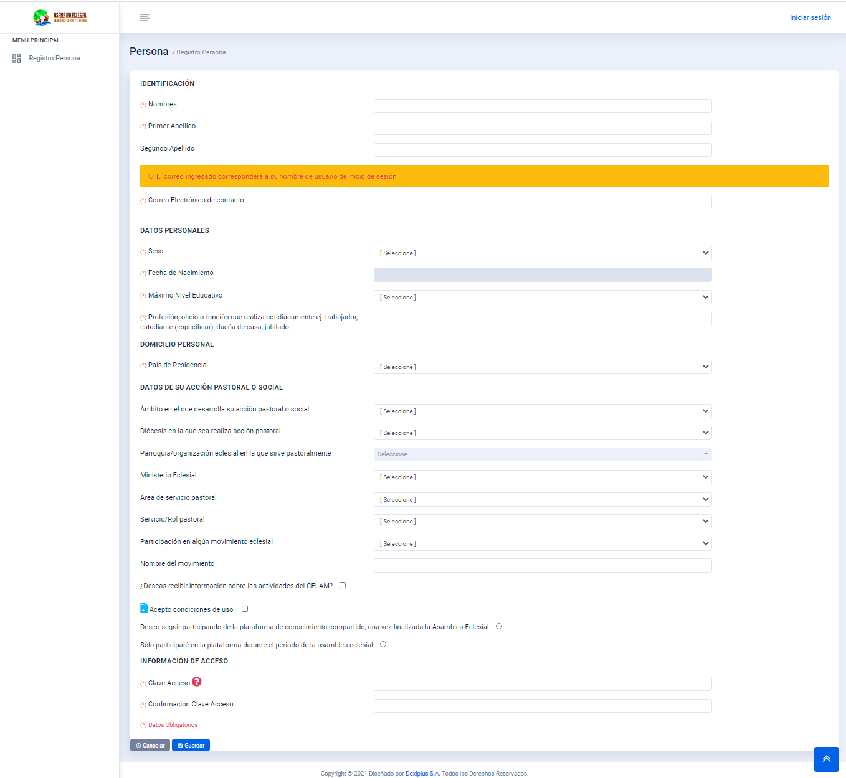
3
After completing the requested information, press the button
and you’ll be granted access using your e-mail and the password you entered.

After registering for the first time, you will have direct access to the platform.
4
From the second login on you will need to enter your e-mail in the “User” field and the password you used in your registration form in the “Password” field. Then click “Log In” 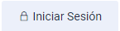 button.

If you don’t remember your password, click on the “Forgot password” link.
When you press the “Forgot my password” option, the system will request you to select the “Access type”, where you must select the “User” option. Then you must enter your e-mail and click on “Reset password”.
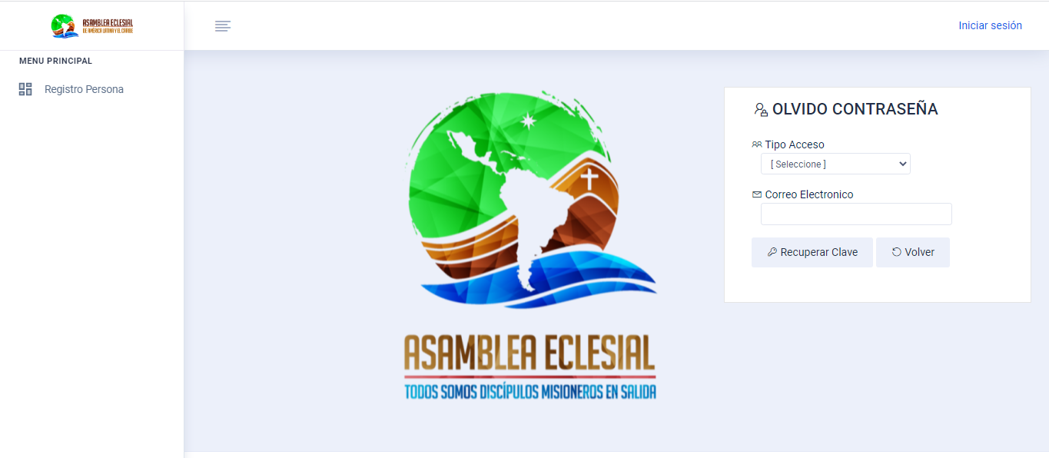
After pressing the “Reset password” , the system will display the following message: “A new temporary password to access the system has been sent to the registered email”.
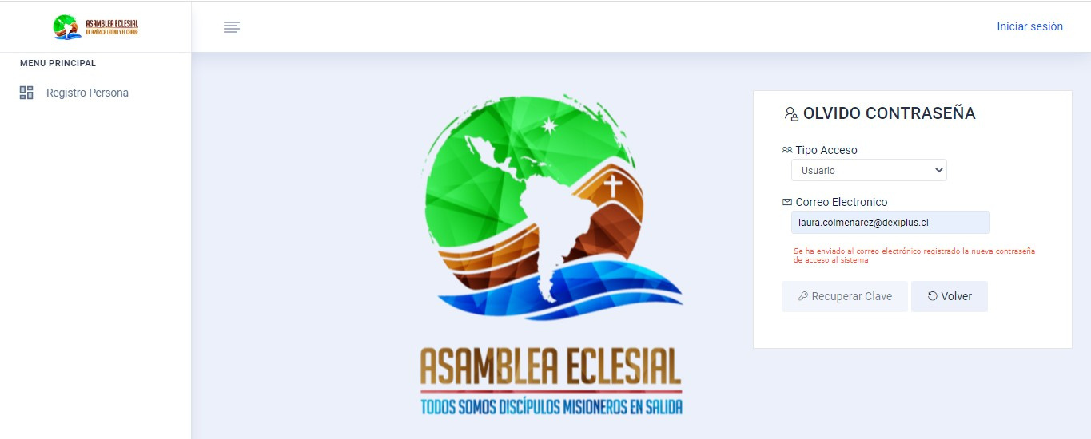
You will receive a message in your email with your new password.
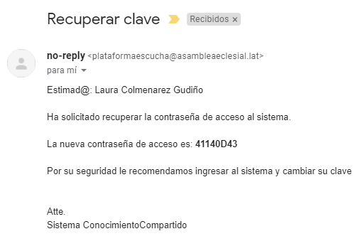
123456

If you want to change the password, once you log in to the system enter the main menu, search for the option “My Profile” and then click on the “Change password” button.
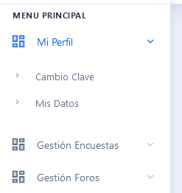

When you log in to the system, the following icons will be displayed:
5
- Personal Participation (“Participación Personal”): the current active Personal Participation Survey will be displayed.
- Group participation (“Participación Grupal”): the current active Group Participation Survey will be displayed.
  - Thematic Forums (“Foros temáticos”): this option will list the active forums.
  - Surveys (“Encuestas”): by clicking this button you’ll be able to see other available surveys.
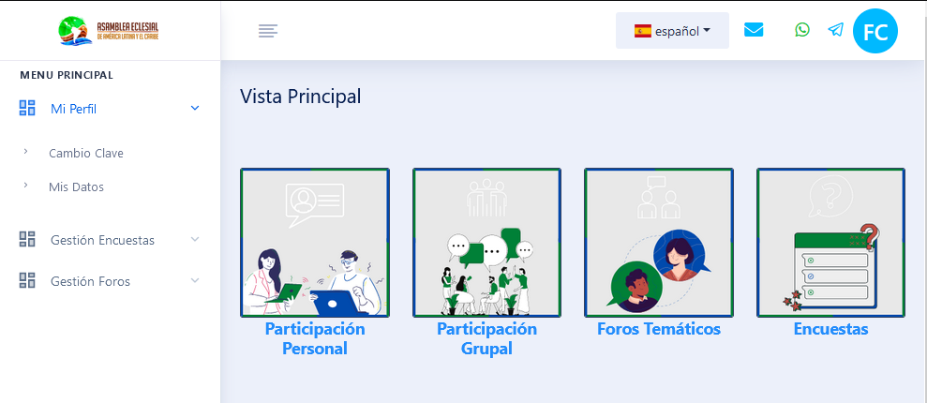

Personal Participation (Participación personal):
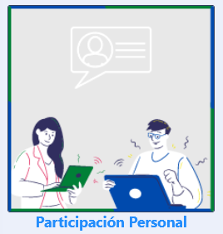 When you access the “Personal Participation” option, you’ll see this screen:
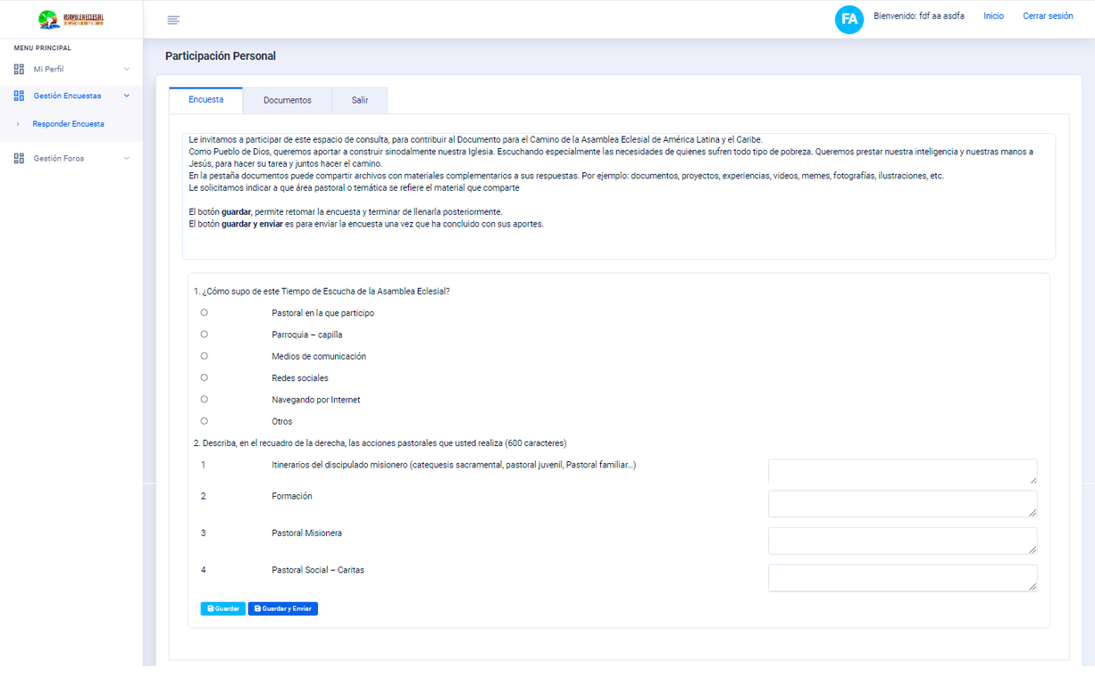
Within the survey, you can answer as many questions as you want. You can also share files with complementary contents in the “Documents” tab. For example: Documents, projects, experiences, videos, memes, photos, illustrations, etc.
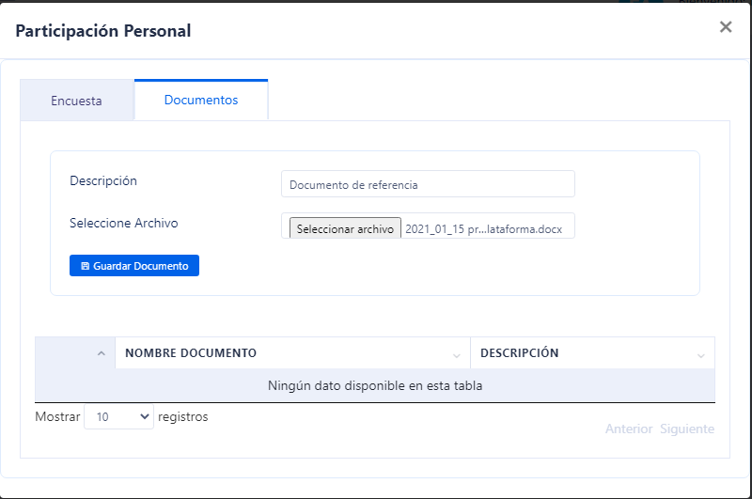
To attach a file: enter a description of the file. Click “Browse…” and choose the file you want to attach. Finally click “Save file”.
The system will add the chosen file to the list, and you’ll be able to remove or download it.
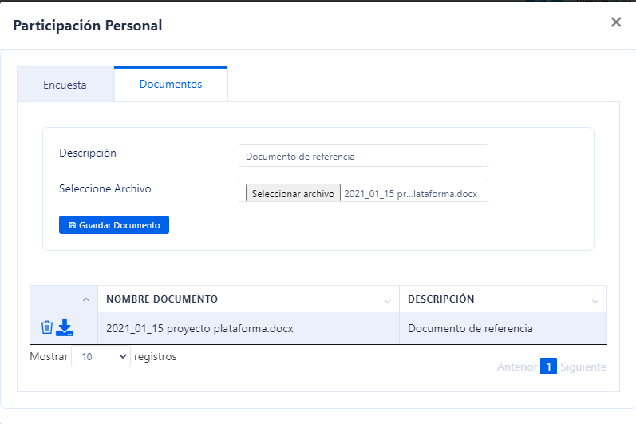
When you finish uploading the documents, choose the “Survey” tab 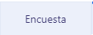.
The system will display the answers entered by the user. You may choose between “Save” or “Save and send” . The first button will let you return to complete or modify your survey at some other time. The second button sends the survey and you can no longer be allowed to modify it.

Group Participation
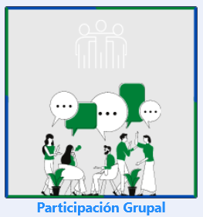
When you access the “Group Participation” option the system will display the current active survey of this type.
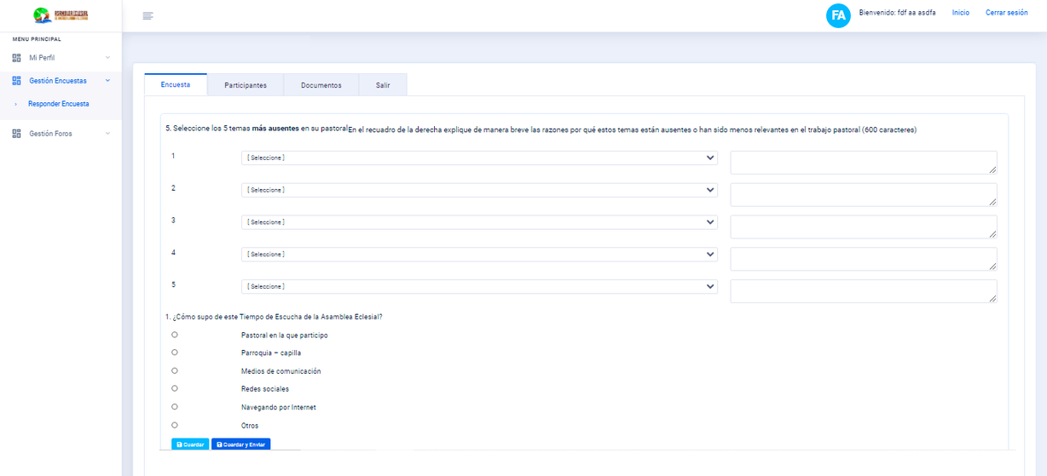
Within the survey you can enter the answers agreed with your group and then go to the “Participants” tab to add the people who took part in the group survey.
Within this option, both registered people and people who do not have registration in the system are entered.

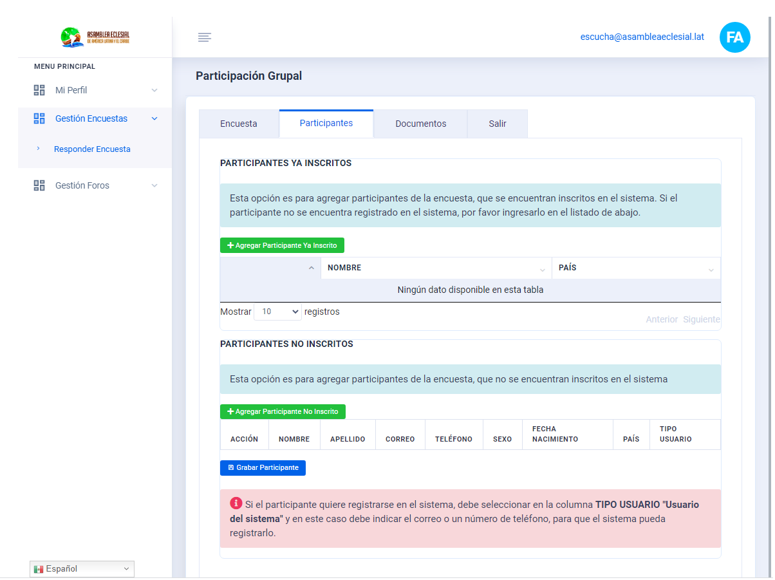
To add the people who are registered in the system, you must click “Add Registered Participant” . The system will display search fields by: e-mail or phone number. After entering the desired search criteria, click on “Search participant”
The system will list the people who match the search criteria; then you must select the person and click “Save participant” .
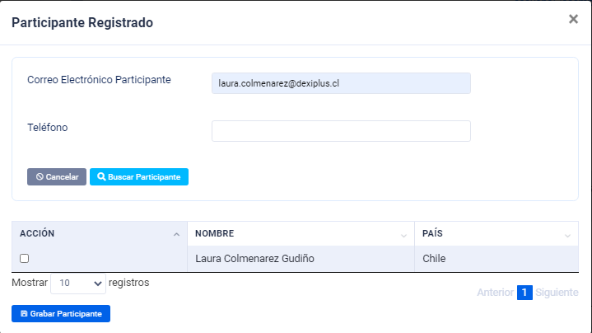
The selected person is then added to the following list:
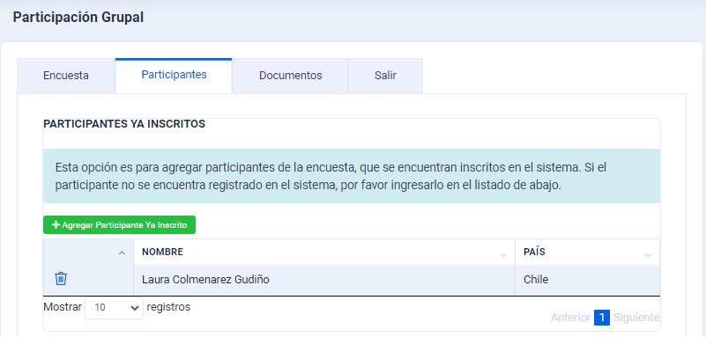

If the people to be added are not registered in the system, click on “Add non-registered participant" on top of the “Non-registered participants”. Upon clicking the button, the system will add a row in the list requesting the following data: ; First Name, Last Name, Email, Phone, Gender, Date of Birth, Country and User Type.
There are two options in the “User type” column:
User: If the person wants to keep participating in the platfom.
Guest: If the person wants to participate in this survey only.
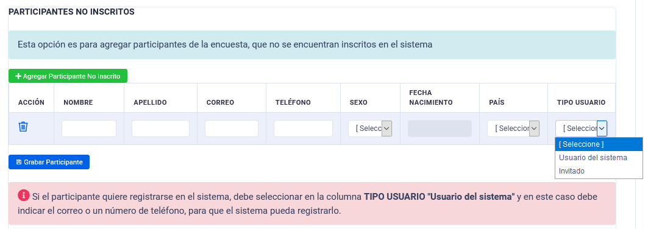
If you want to add more people, click again on “Add non-registered participant” and repeat these steps. Once all participants have been added, click on “Save participant”
After adding the participants of a survey, you can attach files by choosing the “Files” tab to complement the group or community’s answers. For example: documents, projects, experiences, videos, memes, photos, illustrations, etc.
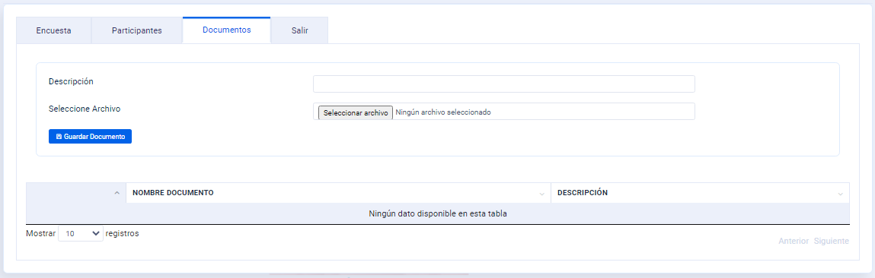
To attach a file: enter the description of the file. To attach the file, click on “Browse…” and choose the file you want to upload. Finally, click “Save file” .
The system will add the selected file to the list, and give you the option to delete or download that document.

When you finish uploading the documents, select the “Survey” tab.
The system will display the entered answers. Finally, you can choose between the buttons “Save” or “Save and Send”. The first one will allow you return and complete or modify your survey at some other time. The second sends the survey and you can no longer modify it.

Surveys
If you wish to participate in other surveys, you may access the “Surveys” option.
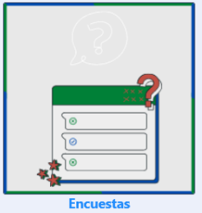
The list shows all available surveys for the user who logged into the system. To participate in one of them, click on and follow the steps described in the “Personal Participation” or “Group Participation” sections.
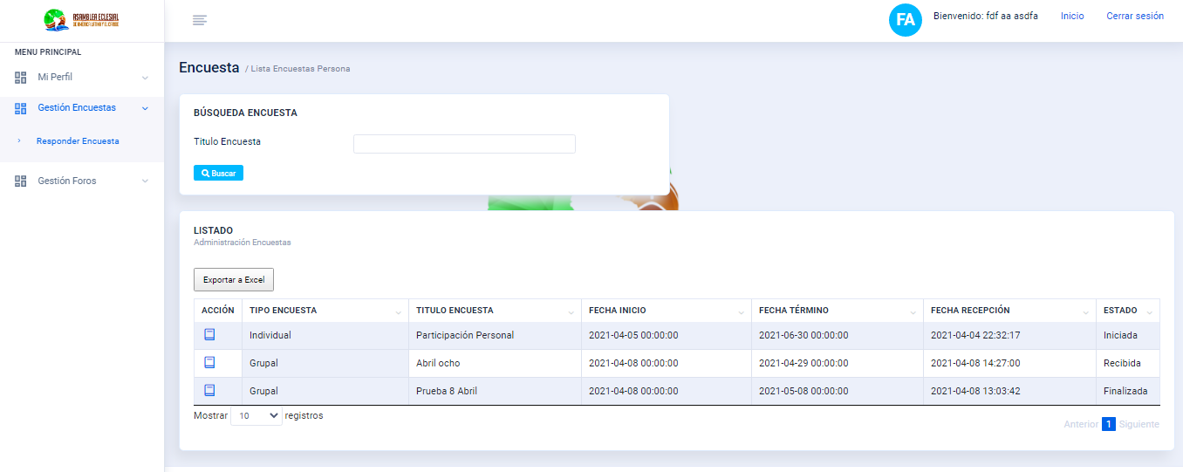

Thematic Forums
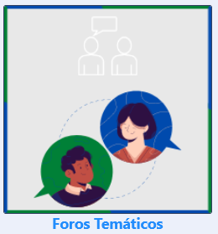
Upon accessing the “Thematic Forums” option, the system shows all available forums where the user can participate.
Click “Participate in forum” , on the bottom right of the forum you’re interested in.
By pressing the button indicated above, the system will display the forum’s information and the comments the users have posted.
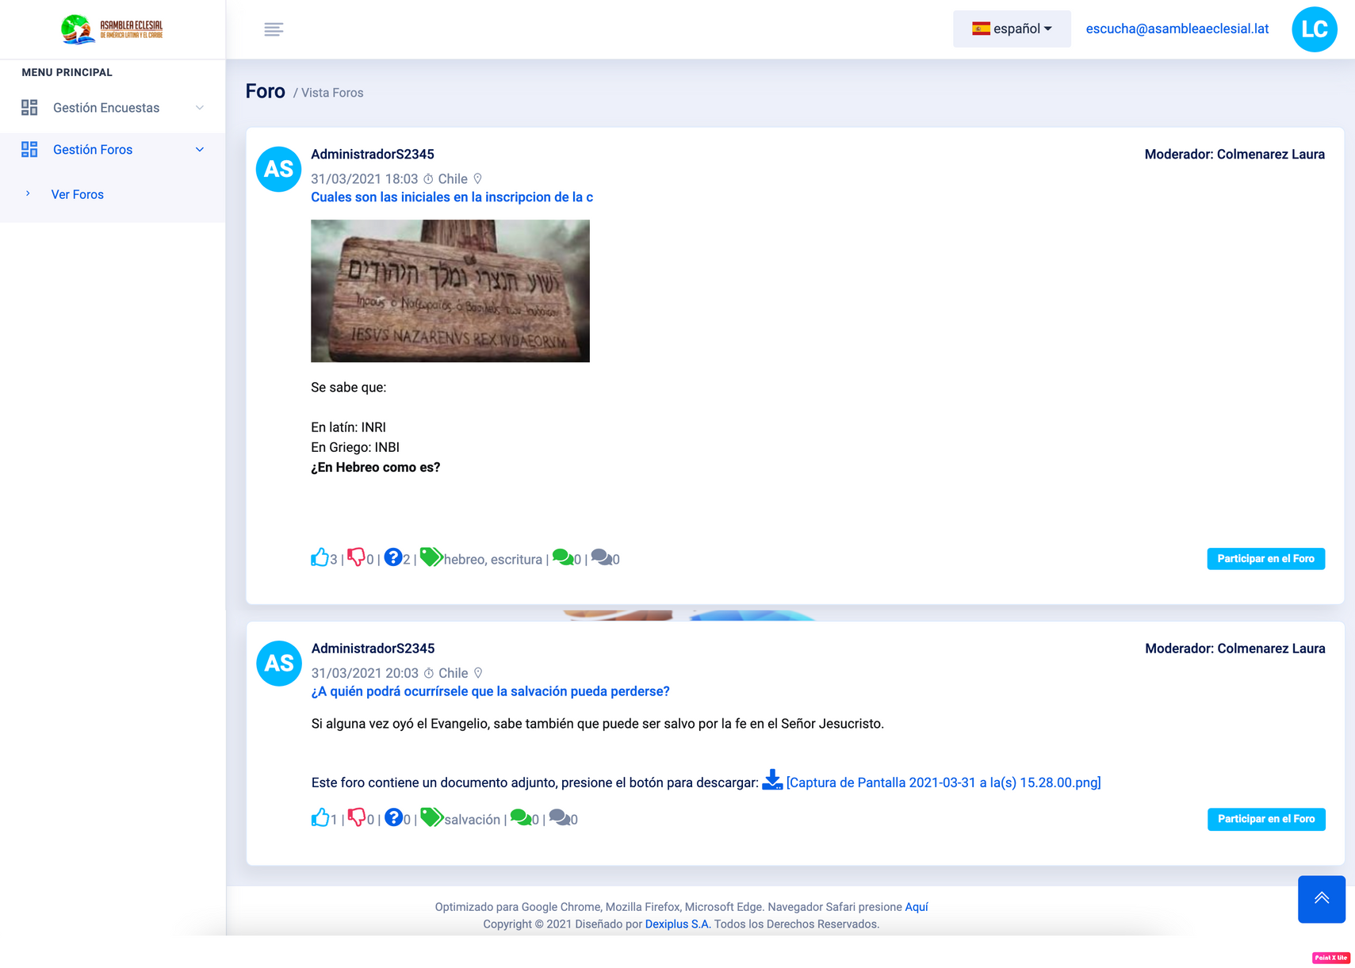
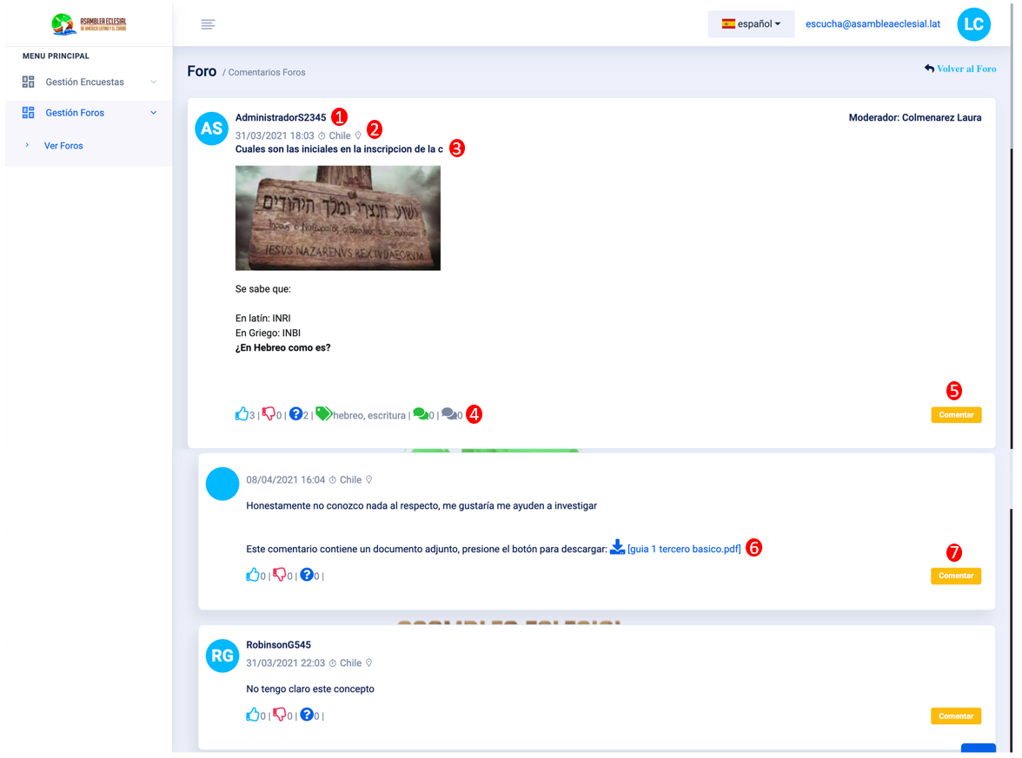
① Username of the creator of the forum.
② Date and time of creation and country where the user who created the forum is located.
③ Headline or Forum Title.
④ Supported reactions and forum information:
- Click if you like the answer or post.
- Click if you dislike the answer or post.
- Click if you did not understand the forum information.
- Shows the tags (descriptions) assigned to the forum.
- Indicates the number of unread comments within the forum.
- Indicates the number of read comments within the forum.
⑤ Select the “Comment” button to post an answer in the forum. When you press it, the system will display a window in which you can enter a comment and attach a complementary file (using the “Choose file” button). To post the comment, click “Save comment” .
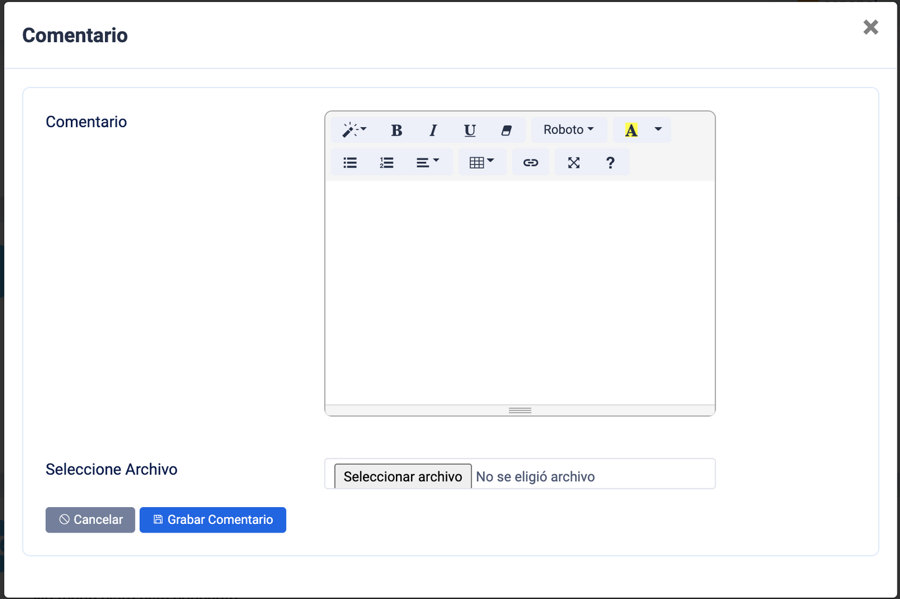
⑥If a comment has attachments, click on this button to download them.
⑦ The “Comment” button allows you to comment on another user’s post. . By pressing it, the system displays a window where you can enter your opinion and attach a complementary file (through the “Select file” button). To post the comment, click on “Save comment”

